CS 340 Project Two README
Grazioso Salvare Dashboard (MongoDB + Dash)
Author: Steve Gifford
Course: CS 340 Client/Server Development

About the Project
This project is a client-facing dashboard for Grazioso Salvare that connects to the Austin Animal Center Outcomes dataset stored in MongoDB. The dashboard provides interactive filtering options to identify dogs that match Grazioso Salvare’s search-and-rescue training profiles, along with dynamic visualizations (a geolocation map and a secondary chart) that update automatically when filters are applied.

Motivation
Grazioso Salvare needs a simple, user-friendly interface to reduce training time and user error when reviewing shelter animal data. Rather than requiring staff to write database queries directly, this dashboard provides intuitive filter controls and visual widgets that present the filtered results clearly.

Required Functionality (Per Spec)
The dashboard includes:
- Branding: Grazioso Salvare logo with a clickable link to the client home page (www.snhu.edu).
- Branding: Unique identifier containing my name on the dashboard.
- Interactive filter options for: Water Rescue, Mountain or Wilderness Rescue, Disaster or Individual Tracking, and Reset.
- An interactive data table that dynamically updates based on the selected filter.
- A geolocation widget (map) that updates based on the filtered data and selected row.
- A second chart of choice (pie chart) that updates based on the filtered data.

Filter Definitions
The filter queries match the client-provided rescue profiles:
Rescue Type | Preferred Breeds | Preferred Sex | Training Age (weeks)
Water Rescue | Labrador Retriever Mix; Chesapeake Bay Retriever; Newfoundland | Intact Female | 26–156
Mountain/Wilderness Rescue | German Shepherd; Alaskan Malamute; Old English Sheepdog; Siberian Husky; Rottweiler | Intact Male | 26–156
Disaster/Tracking | Doberman Pinscher; German Shepherd; Golden Retriever; Bloodhound; Rottweiler | Intact Male | 20–300

Tools Used
MongoDB / mongosh: Database used to store and query the AAC dataset.
PyMongo: Python driver used inside the CRUD module to connect to MongoDB and run queries.
Dash + JupyterDash: Web framework used to build the dashboard UI and run it inside the Codio Jupyter environment.
dash_table.DataTable: Interactive data grid used for filtering, sorting, paging, and row selection.
Plotly Express: Used to generate the pie chart widget.
Dash Leaflet: Used to render the interactive geolocation map widget.
base64: Used to embed the logo image directly into the dashboard.

Why MongoDB?
MongoDB is well-suited for this dataset because the shelter records are naturally represented as flexible JSON-like documents. MongoDB supports fast filtering on optional fields, and integrates cleanly with Python through PyMongo for reusable CRUD operations.

Why Dash?
Dash provides a Python-first way to create interactive web dashboards without writing separate front-end code. Dash callbacks make it straightforward to follow an MVC-style structure: MongoDB and the CRUD module act as the model, the layout/widgets act as the view, and callbacks act as the controller that connects user inputs to queries and updated visualizations.

Project Structure
Typical files included in the submission zip:
- ProjectTwoDashboard.ipynb (dashboard code)
- animal_shelter.py (CRUD module from Project One)
- Grazioso Salvare Logo.png (provided course asset)

How to Run (Codio / Jupyter)
- Ensure MongoDB is running in the Codio environment and the AAC dataset is available.
- Place animal_shelter.py in the same directory as ProjectTwoDashboard.ipynb (or update the import path).
- Verify the logo file name matches exactly: 'Grazioso Salvare Logo.png' (same folder as the notebook).
- Open ProjectTwoDashboard.ipynb and run cells from top to bottom.
- When the server starts, open the provided dashboard URL (Codio proxy to port 8050).
- Use the radio buttons to apply filters and confirm the table, pie chart, and map update for each option.

Credentials
This project uses the course-provided MongoDB user for authentication:
Username: aacuser
Password: SNHU1234
Note: These credentials are provided for the course environment only.

Testing and Screenshots
I verified that each dashboard widget updates correctly when a filter is selected. The screenshots below are required proof of functionality. Each screenshot must clearly show the Grazioso Salvare logo and the unique identifier with my name.
Insert screenshots here:

Screenshot 1: Starting state (Reset / unfiltered)
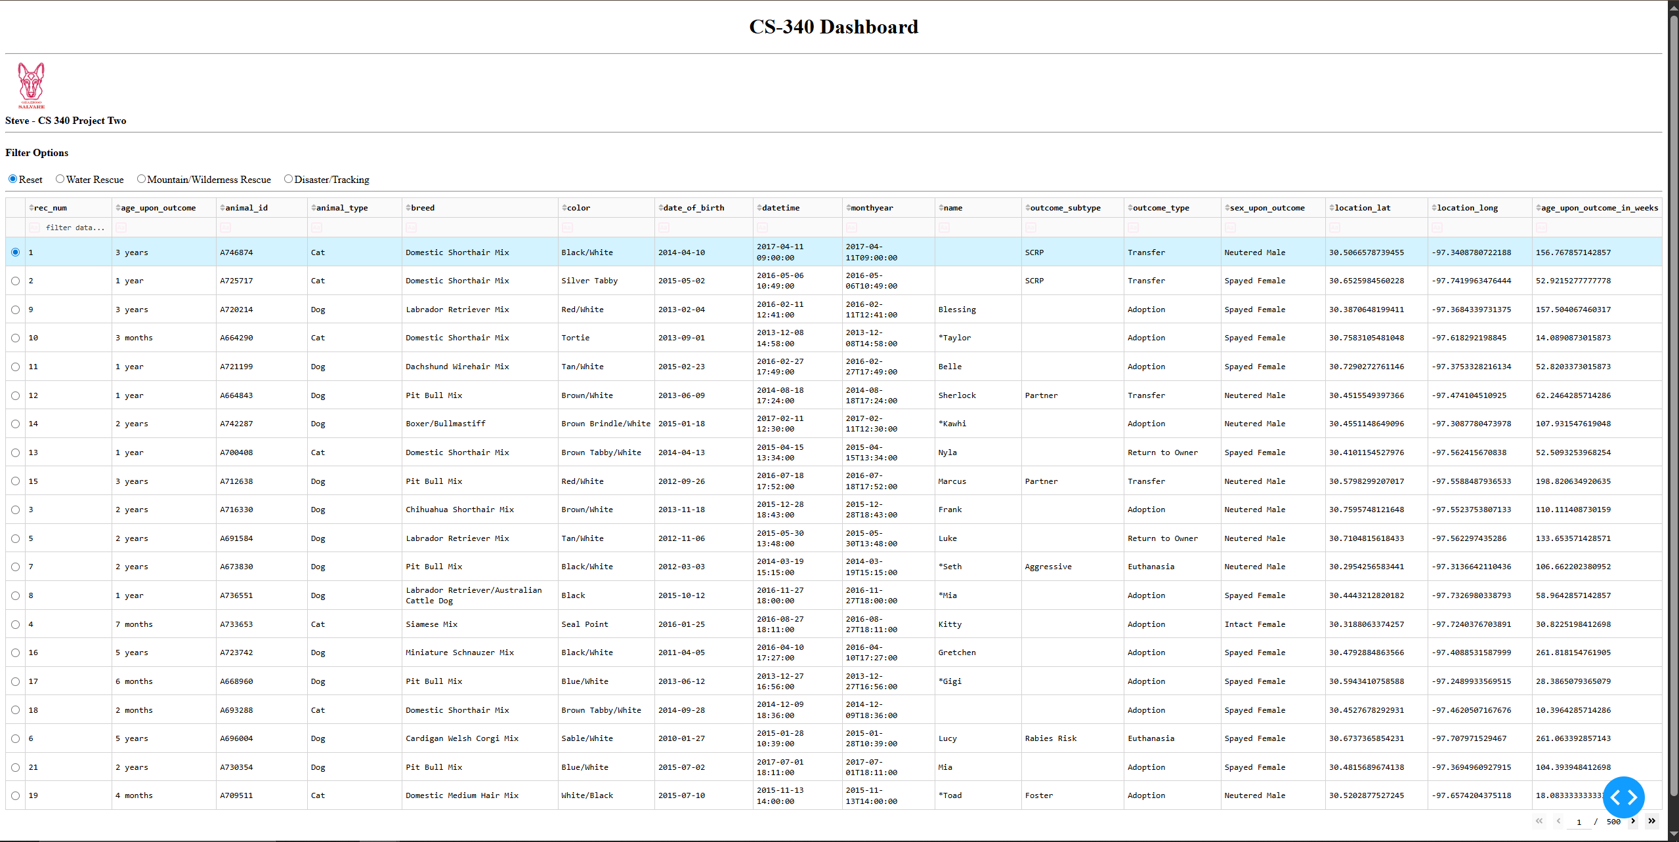Screenshot 2: Water Rescue filter applied
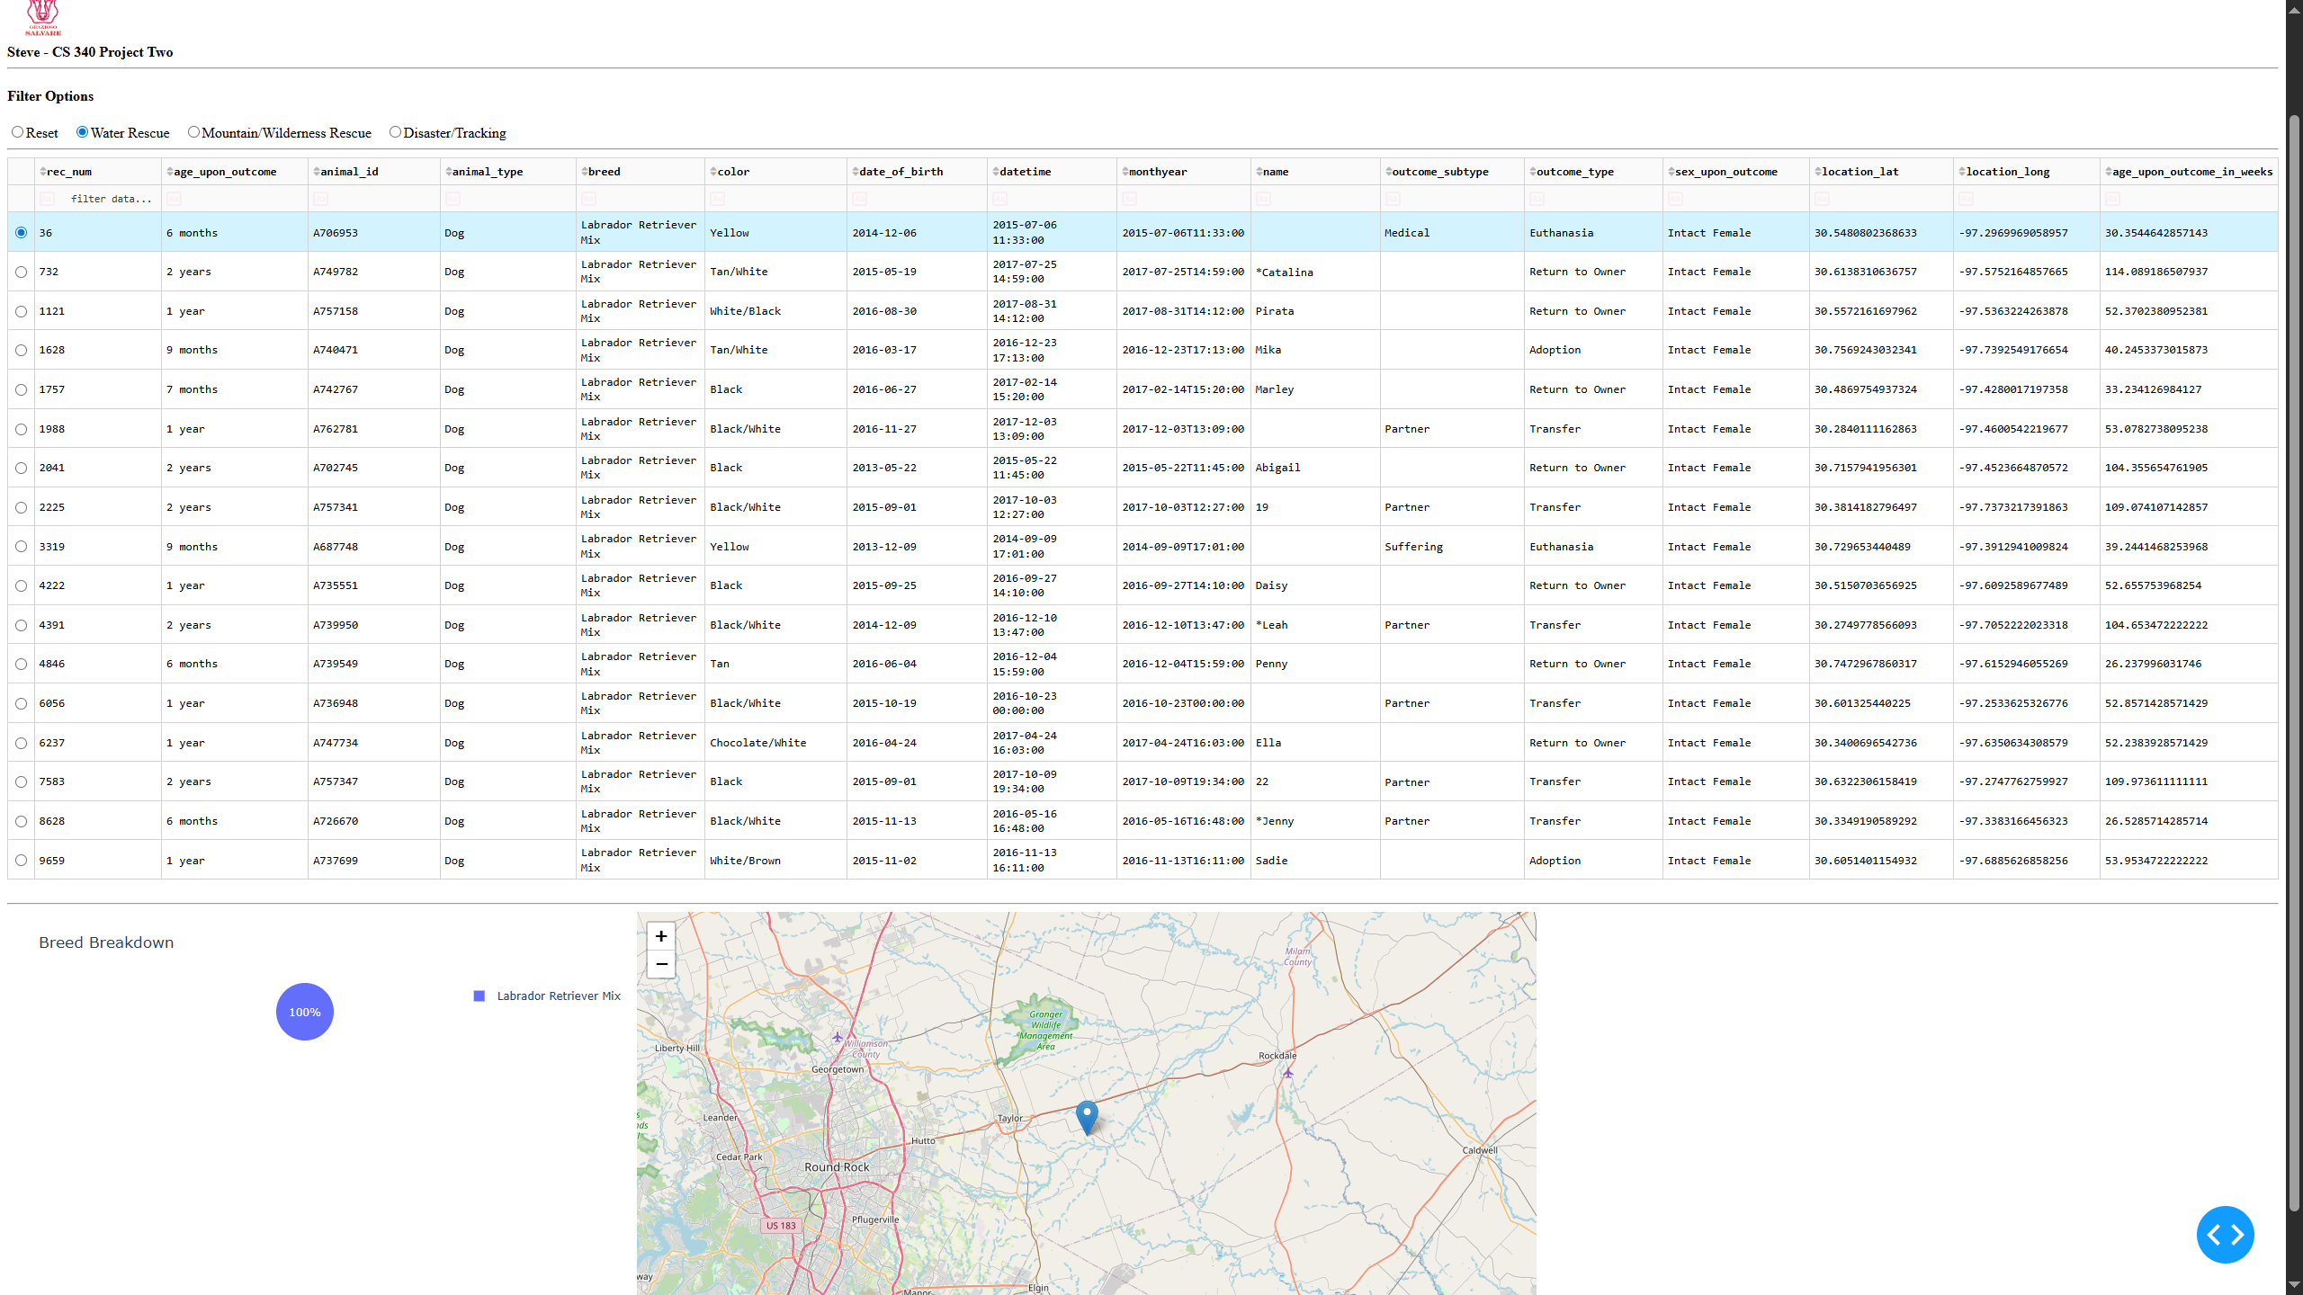

Screenshot 3: Mountain or Wilderness Rescue filter applied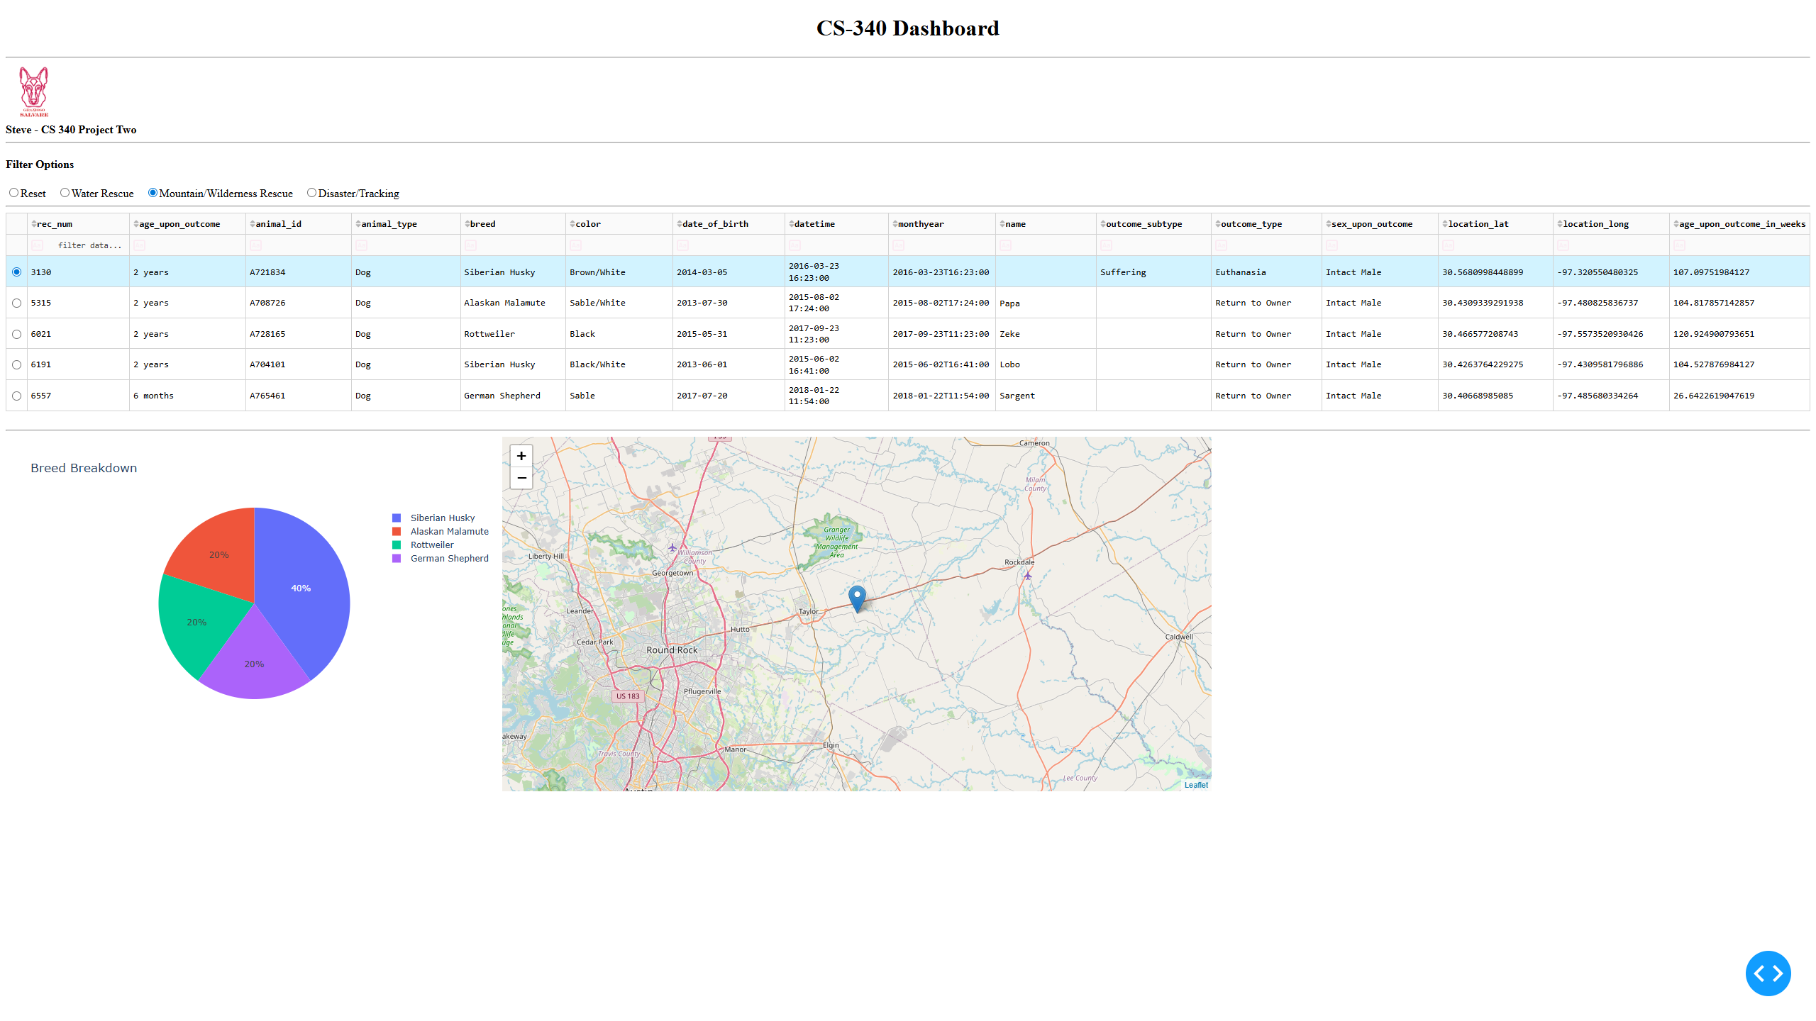Screenshot 4: Disaster or Individual Tracking filter applied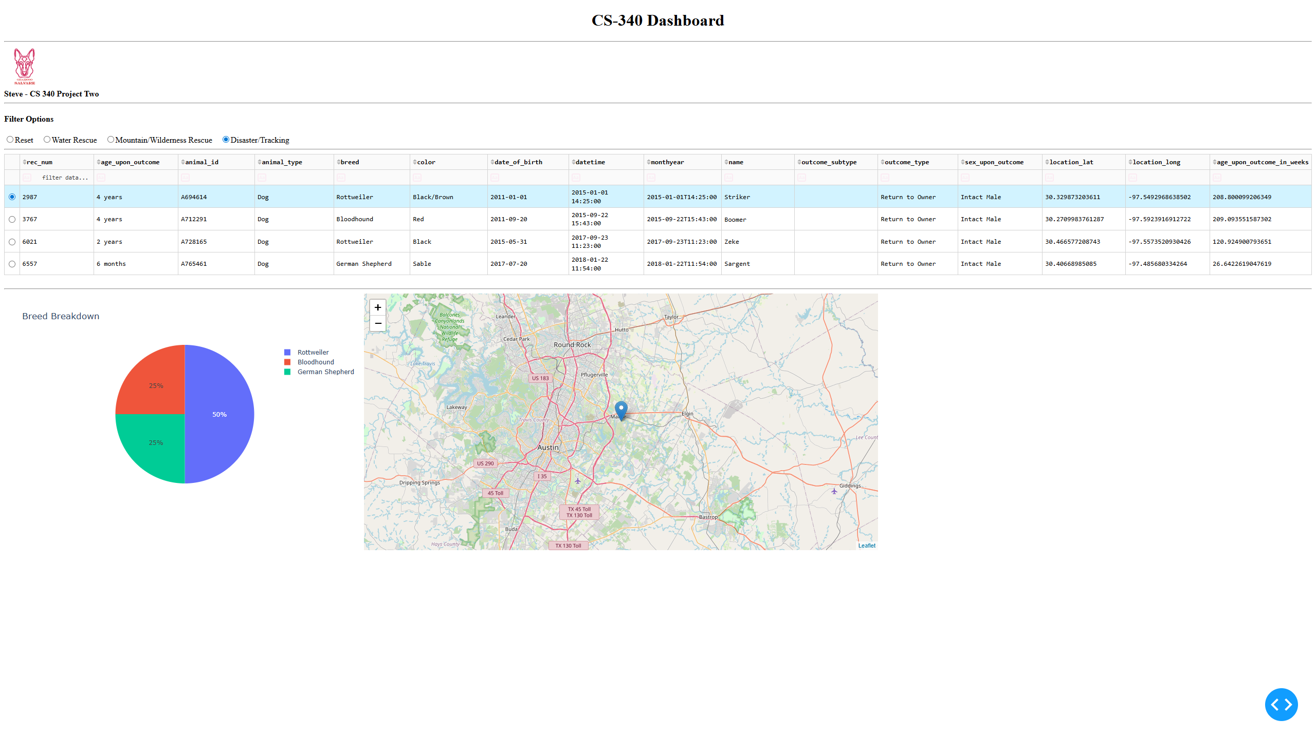Challenges Encountered and Solutions
MongoDB ObjectId in '_id' caused DataTable issues: MongoDB returns an ObjectId type that Dash cannot serialize cleanly. I resolved this by dropping the '_id' column from the initial DataFrame and removing '_id' from query results before returning data to the DataTable.
Filter queries needed to match the specification exactly: I created a single dictionary (RESCUE_FILTERS) that hard-codes each rescue profile’s breed list, preferred sex, and age range in weeks, then used the selected radio value to choose the correct query.
Keeping the map stable when no row is selected: I defaulted to the first row of the filtered dataset when no row is selected, and added bounds checks so the app does not crash if the selection index is missing or out of range.

Resources
Documentation and references used:
- Dash documentation: https://dash.plotly.com/
- Dash DataTable documentation: https://dash.plotly.com/datatable
- JupyterDash documentation: https://github.com/plotly/jupyter-dash
- Plotly Express documentation: https://plotly.com/python/plotly-express/
- Dash Leaflet documentation: https://dash-leaflet.herokuapp.com/
- MongoDB + PyMongo documentation: https://pymongo.readthedocs.io/

